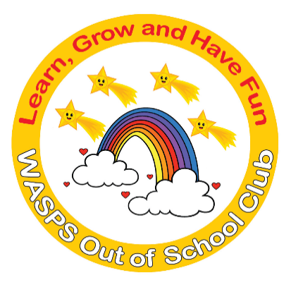
WASPS Out of School Club

Privacy Policy
This privacy policy sets out how the WASPS Out of School Club uses and protects any information collected when you use its website.
WASPS Out of School Club is committed to ensuring that your privacy is protected. Any information by which you can be identified when using this website will only be used in accordance with this privacy statement.
WASPS Out of School Club may change this policy by updating this page. You should check this page from time to time to ensure that you are happy with any changes and each time before you submit your personal information.
At WASPS Out of School Club we respect the privacy of the children attending our clubs and the privacy of their parents or carers. The personal information that we collect about you and your child is used only to provide appropriate care for them, maintain our service to you, and communicate with you effectively. Our legal basis for processing the personal information relating to you and your child is so that we can fulfil our contract with you.
Any information that you provide is kept secure. Data that is no longer required is erased after you have informed us that your child has ceased attending our club.
We will use the contact details you give us to contact you via phone, text, email, social media, through our online booking system and post so that we can send you information about your child, our club and other relevant news, and so that we can communicate with you regarding payment of our fees.
We will only share personal information about you or your child with another organisation if we:
- have a safeguarding concern about your child
- are required to by government bodies or law enforcement agencies
- engage a supplier to process data on our behalf
- have obtained your prior permission.
You have the right to ask to see the data that we have about yourself or your child, and to ask for any errors to be corrected. We will respond to all such requests within one month. You can also ask for the data to be deleted, but note that:
- we will not be able to continue to care for your child if we do not have sufficient information about them
- even after your child has left our care, we have a statutory duty to retain some types of data for specific periods of time* so cannot delete everything immediately.
If you have a complaint about how we have kept your information secure, or how we have responded to a request to access, update or erase your data, you can refer us to the Information Commissioner’s Office (ICO).
By agreeing to our Terms and Conditions you are giving permission for us to contact you regarding relevant matters.

What Information do we collect:
You may browse the web site without telling us who you are or revealing any personal information. The only information we gather during general browsing is from standard server logs. These include your IP address, domain name, browser type, operating system, and information such as the website that referred you to us, the files you downloaded, the pages you visit, and the dates/times of those visits. This information is not used to develop a personal profile of you. The log files are regularly purged.
You may however provide us with personal information, for example, if you register for any of our services. You may be asked for:
- Name and personal details
- Contact information including email address
- Demographic information such as postcode, preferences and interests
- Other information relevant to customer surveys and/or offers
- Payment details (such as debit or credit card details) if paying for a service. WASPS Out of School Club do not store our customers’ financial details.
What do we use personal information for?
We require this information to understand your needs and provide you with a better service, and in particular for the following reasons:
- Internal record keeping.
- We may use the information to improve our products and services.
- We may periodically send promotional emails about new products, special offers or other information which we think you may find interesting using the email address which you have provided.
- From time to time, we may also use your information to contact you for market research purposes. We may contact you by email, phone, fax or mail. We may use the information to customise the website according to your interests.
- We may use your personal information to send you promotional information about third parties which we think you may find interesting if you tell us that you wish this to happen.
Who do we pass your personal information to?
We will only disclose personal information to government bodies and law enforcement agencies, successors in title to our business and suppliers we engage to process data on our behalf.
We will not sell, distribute or lease your personal information to third parties unless we have your permission or are required by law to do so.
If you believe that any information we are holding on you is incorrect or incomplete, please write to or email us as soon as possible, at the above address. We will promptly correct any information found to be incorrect.
Security
We are committed to ensuring that your personal information is secure. Whilst we make all reasonable efforts to maintain security of your personal information, we assume no responsibility for the security of such information.

How we use cookies
A cookie is a small file which asks permission to be placed on your computer’s hard drive. Once you agree, the file is added and the cookie helps analyse web traffic or lets you know when you visit a particular site. Cookies allow web applications to respond to you as an individual. The web application can tailor its operations to your needs, likes and dislikes by gathering and remembering information about your preferences.
We use cookies to recognise members who have previously logged in and to ensure that restricted member content is delivered correctly.
We use traffic log cookies to identify which pages are being used. This helps us analyse data about web page traffic and improve our website in order to tailor it to customer needs. We only use this information for statistical analysis purposes.
Overall, cookies help us provide you with a better website, by enabling us to monitor which pages you find useful and which you do not. A cookie in no way gives us access to your computer or any information about you, other than the data you choose to share with us.
You can choose to accept or decline cookies. Most web browsers automatically accept cookies, but you can usually modify your browser setting to decline cookies if you prefer. This may prevent you from taking full advantage of the website.
If you have a complaint about how we have kept information secure, or how we have responded to a request to access, update or erase your data, you can refer us to the Information Commissioner’s Office (ICO).

* We do need to retain certain types of data (such as records of complaints, accidents, and attendance) for set periods of time after your child ceases to be in our care, but we delete as much personal data as we can as soon as possible.

